S.M.A.R.T. Goals
Workbook

By Dr. Richard Feenstra
August 2016

Table of Contents

- Statement of Purpose ………………………………………………………… 3

- Eight Shirts and a Laptop …………………………………………………… 3

- How to Use this Workbook ………………………………………………… 3

- The S.M.A.R.T Model …………………………………………………………... 4

- Specific ………………………………………………………………………………. 4

- Measurable ………………………………………………………………………… 5

- Actionable ………………………………………………………………………….. 7

- Relevant ……………………………………………………………………………... 9

- Time Bound ……………………………………………………………………… 10

- Summary ………………………………………………………………………….. 12

- Additional Material ………………………………………………………….. 13

- Guide and Worksheets …………………………………………………….. 14

Statement of Purpose
As the title suggests, this is a workbook. More specifically, it is a workbook you can use to learn about and harness the power of SMART goals. Still, telling you what it is, is different than telling you the purpose it serves. Why should you commit time and resources to learn how to use this workbook?

This workbook was created to help you better structure your goals so that you can accomplish more in less time, so that you are more efficient, more focused, and more productive. It is the purpose of this short book to provide you a proven way to achieve more success.

Before moving on, I want to point out that this is not necessarily an easy process. The term “work” is part of workbook. When I first started using the SMART format to pursue my goals it took me several hours that turned into a few days to really work through which goals were most relevant. Then it took me more time to figure out how I wanted to go about achieving success, establishing my sub-goals and my next actions. A few years later, I now review my goals once a week and it only takes me 30 minutes, no more than an hour to update my progress.

Eight Shirts and a Laptop
At the end of 2011, I decided to sell everything and live a mobile lifestyle. Since then I have lived in Colombia, Ecuador, Peru, Vietnam, the Philippines, and India. In 2015, I spent a couple of months traveling through Greece, Italy, Spain, and Portugal. My current adventure has taken me to China for 4 months. I have now visited over 30 countries and my list continues to grow. It has been a tremendous experience. Since 2011, I have lived out of a carry-on bag and a personal bag. My carry-on has my eight shirts, and my personal bag I call, “The Office.”

Travel has not been my only goal. As an educational psychologist, I now have over 20,450 students from 164 countries around the world. I have learned Spanish and have successfully learned several new skillsets that have helped me grow both personally and professionally. So far this year, I have read 16 books. This workbook was a small, short-term goal accomplished using SMART.

While certainly SMART is not the only way to achieve what you want, it has definitely worked for me. And while certainly success is a relative concept, I hope my story is at least slightly inspiring for anyone that wants to achieve more in less time.

How to Use this Workbook
If you are not familiar with SMART goals, then I suggest reading the workbook from start to finish. Once finished, use the worksheets to establish your goals step-by-step. On the other hand, if you are already familiar with the SMART model, even if the model you used is a different variation than the one presented here, you can probably go straight to the worksheets while using the workbook more as a reference.

The S.M.A.R.T. Model
George T. Doran, is generally credited with the original development of the SMART model in a 1981 paper that he published in the journal “Management Review”, titled "There's a S.M.A.R.T. Way to Write Management's Goals and Objectives".

In the original version, Doran defined SMART as:

- Specific: target a specific area for improvement.
- Measurable: quantify, or at least suggest, an indicator of progress.
- Assignable: specify who will do it.
- Realistic: state what results can realistically be achieved.
- Time-related: specify when the result can be achieved.

Since the original format a wide range of other variants have surfaced. The most common use the ‘A’ as achievable and some versions extend the model to include an ‘E’ and an additional ‘R’ to form SMARTER goals. The second ‘R’ is most often used to refer to resources, asking the individual to consider to what extent the resources are available to achieve the goal.

In this workbook, a version of SMART is used that addresses the reality that in life we most often are in pursuit of multiple goals, not a single goal in isolation. In order to address this aspect of goal setting, the format discussed is:

- Specific: be precise in what you want to achieve.
- Measurable: quantify performance and outcomes.
- Actionable: state next actions and milestones.
- Relevant: determine priorities.
- Time Bound: develop feedback loops and time lines.

Specific
Many times when people are asked, “What are your top goals in life?” Common responses include to be healthy, wealthy, happy, to travel the world, or to write the next great novel. While these responses are goals, they are not specific. In fact, they are so general that they are more appropriately defined as visions of some mental picture of an ideal future state. And while it is good to have vision, research has shown when it comes to actual achievement of a goal, being specific is important.

In over 400 laboratory and field studies, it has been demonstrated repeatedly that specific, challenging goals lead to a higher level of achievement than easy goals that are vague or abstract, e.g. telling a person to “do one's best.” The underlying theory is that when a goal is specific, this provides clarity, helping when it comes to mentally constructing a plan for success and providing motivation for some individuals.

In being specific, you need to define your goals in terms of the precise result you want to achieve. If you cannot be exact, then at least a range. For instance, what does it mean to have a goal to be healthy or wealthy? These are subjective goals that lack definition. Is being a millionaire even considered wealthy anymore? What about health? For most, being healthy means being capable of a certain physical activity such as running a marathon or being a certain weight. Therefore, if your vision is to be healthy, set a goal like run two miles in under 15 minutes or get your body mass index (BMI) to twenty.

Generally speaking, the more specific you can make a goal the better. The more specific, the easier it becomes to establish other aspects of the goal. The less specific your goals, the more difficult it will be to measure success, to determine the actions you need to take, to figure out how one goal relates to another and to establish time boundaries.

Measurable
This is arguably my favorite part of goal setting and an area where I think it is easy to get off track by establishing measurements that are less than helpful. In fact, I think in our digital world getting off track is easier than any other time in history.

The most common error I see is establishing measurements that track results, but not performance. I think in order to obtain the best results you should try to use both. The second most common error is allowing the way you decide to measure to drive your goal instead of the goal driving the way you measure. Last, I want to cover the concept of triangulation, discussing when and why you might want to use multiple measurements.

Outcomes vs. Performance
A simple example is the common goal to lose a specific amount of weight as part of a resolution to live a healthy life. For purposes of the example let's say you determine that you could stand to lose 10 pounds. This provides you a result or outcome that you want to achieve and you can easily monitor how your goal is progressing by using a scale to weigh yourself periodically. Still, establishing this measurement does nothing to help you as it relates to actual performance.

A performance measure on the other hand is a particular action you can take that is measurable, and that you have reason to believe will help you achieve results. In trying to lose weight common methods include diet, exercise or taking a supplement. For diet you can track the number of calories you eat each day and for exercise you can track the number of calories burned or the total distance you walk or run. The supplement is a matter of tracking the frequency. These are all actions you can take that are based on some task you need to perform. From these measures or variables you can begin to tie your performance to results. As the general wisdom goes, performance drives results.

Measuring What You Manage
Speaking of general wisdom, management expert Edward Deming is known for his statement, "What gets measured gets managed." If you set a performance measure to eat less than 2,000 calories a day then it is this aspect of the goal to lose weight that will get managed. And, management requires resources, including time and energy. Given we all have a finite amount of resources available, a sneaky trap you want to avoid is allowing a method of measurement to dictate what you will manage.

Sticking with the fitness theme, a growing trend is wearable technology that helps measure all sorts of neat statistics. Fitbit is a popular brand of wearable tech, providing a wireless wristband to help track things like heart rate and even the number of flights of stairs you walk up each day. Because of these measurements, it is tempting to fall into the trap of searching for stairs you can climb or trying to develop a fitness routine to use the heart rate monitor. If you are not careful the measurement tool begins to drive what you are managing instead of the other way around.

An example that is also a growing trend is the use of analytics in business. I love analytics. I think it is fun to check my websites and see people from all over the world visiting. I can see how long they have stayed on the site, what type of the device they used to connect and sometimes I even get data on age and gender. There are hundreds of analytics available from which I can choose and a mountain of data at my fingertips.

It is this mountain of data that becomes the double-edged sword. You want data to help make informed decisions, but you also need to avoid letting analytics be the measure that drives your goals. Instead, you first want to use the data to inform and help establish your goals and only then select the analytics that are the correct measurement tools for the job. It is a subtle, but important difference between measuring what you manage verses managing what you measure.

Triangulation
Another key to measuring a goal is knowing when and why you should use more than one measurement to gauge success. We have already discussed the need to use both performance and outcome measures, but there is another concept called triangulation. The idea behind triangulation is that like the three sides of a triangle, to use three measurements to help verify and validate outcomes.

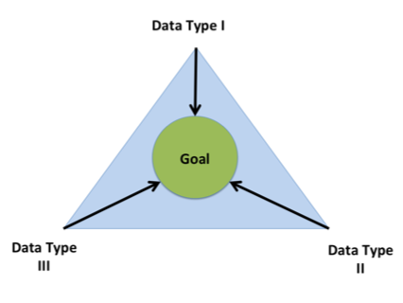

Eating less than 2,000 calories a day is performance based, the expected outcome is a loss of weight. What happens then, if after two weeks no weight has been lost? Having the single measurement weight, it would appear no progress is being made. However, if you also were measuring inches around your waist and body fat percentage, the three measurements taken together may tell a different story.

For goals that are short term, simple or low impact the added effort to manage multiple measurements is probably not worth the resources. But, for goals that are long term, complex or of high consequence, using triangulation is something to consider. For the best results, I recommend using three types of data that include both quantitative and qualitative forms of measurement.

The Bottom Line
A critical part of establishing a goal is to know how you plan to measure success. For better results consider:

- Make sure to use both performance and outcome measures.

- Measure what you manage, not the other way around. First establish your goals, then select the correct measurement for the job.

- For goals that are complex or high consequence and long term, consider using triangulation. Select multiple measurements to validate results and keep you on the right track.

Actionable
A goal without action is just a dream. If measurable is the aspect of goal setting I find most fun, actionable is the component I find most important. An alternate version of SMART uses the term achievable instead of actionable, but for reasons I will talk about next, I personally find actionable to be more useful.

Achievable
I would be remiss to say that it is not good to at least consider the extent to which a goal is achievable. Research has shown that when it comes to goal setting, the most successful individuals are those more capable of accurately making self-assessments of their capabilities and resources available. Those individuals that fail to accurately gauge their abilities or resources are more likely to fail. This may make it seem then, that success is dependent upon setting goals that are achievable.

However, there is also research on motivation that supports what Henry Ford was known to have said, “Whether you think you can, or you think you can’t—you’re right.” As it turns out, your individual beliefs regarding whether or not you can or cannot achieve a goal has a significant impact on success. This includeds if you are motivated to begin working towards a goal in the first place. Individuals with beliefs that support high levels of success set stretch goals, goals that are challenging without the guarantee of achievement.

Consider the extensive list of ludicrous, unachievable goals throughout history that people dared to attempt. There was circumnavigating the earth in a wooden ship, running a mile in under 4 minutes, landing a man on the moon, me being chosen male model of the year, transplanting a human heart, cloning a sheep and the list continues. With recent advancements in technology it seems like the pace at which the once unachievable is being achieved is accelerating at an unprecedented rate.

I admit my personal bias here. It is because of my firm belief in mankind’s ability to achieve the unachievable that I prefer using the term Actionable when structuring my SMART goals. It is within the context of what is actionable that I try to accurately assess my abilities and the resources I have available. I try to determine if my next action is achievable rather than the overall goal.

“Shoot for the moon. Even if you miss, you'll land among the stars.”
- Norman Vincent Peale

Actionable
Instead of achievable, focus on what is actionable, what IS your plan for success? For simple or short-term goals it may not take much effort to quickly write down the exact actions required. On the other hand, for complex or long-term goals the plan for success will most likely be more dynamic. Larger goals more often will require breaking them down into smaller sub-goals or establishing milestones. Generally speaking, whenever I create a new goal, I write down a minimum of my next three actions or sub-goals.

The degree of detail you want in your action plan will vary. While creating a comprehensive action plan might seem ideal, regardless of the type of goal, when it comes to dynamic or long-term goals, you want to focus most of your effort on near term actions and leave the rest for later. The main reason for this approach is because by definition, dynamic goals ebb and flow, so you are better off not wasting time getting too specific with milestones that are distant.

The Bottom Line
Without action a goal is just a dream, therefore when structuring your SMART goals make sure the goal is actionable. To accomplish this, take the end goal and then set intermediate steps or milestones you need to accomplish along the way. After you have determined your milestones, focus on establishing next actions, those actions that will get you to the first milestone. As you progress, the actions you take will provide feedback that you can then use to adjust your plan.

Relevant
Most versions of SMART do not use relevant. In my opinion those versions neglect two key aspects of goal setting, (1) that we all have more goals than the time we have available and (2) that goals are not strictly independent of one another. Versions of SMART that do not use relevant are silent on these issues, providing no guidance on how to evaluate multiple goals. Therefore, to get the most out of goal setting and improve your chances of success, you not only want to make sure your goals are aligned with your vision and your values, but you want to maximize your time and resources to pursue only those goals most relevant to your long-term success.

Value and Effort
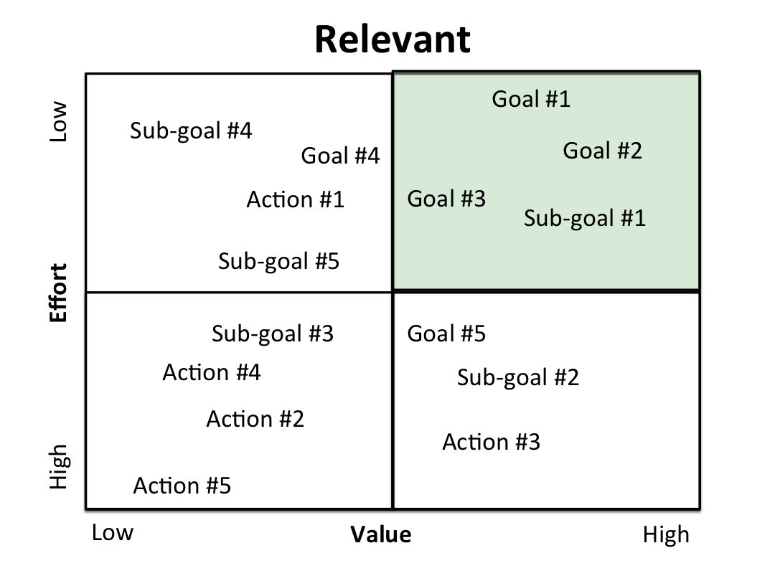
One way to evaluate multiple goals is to place your goals, sub-goals and actions relative to one another on a matrix that looks at perceived value verses effort. When you look across goals, you want to focus your resources pursuing those goals most relevant to your vision that are low effort and high value.
To reinforce, the use of the matrix is a relative process. Hopefully any goal you are looking to achieve has a degree of challenge that will involve substantial effort. The method then, when ranking effort, is simply a comparison between competing goals.

For instance, I have a goal to publish a book. Should I write a work of fiction that tells a story of an evil mastermind and his plans to conquer the world or should I write a book that explains 7 key psychological principles that you can use to harness the power of the human mind? Both would be a challenge to write, both will take significant effort, but given my values and my background as an educational psychologist, the book about the human mind will take less effort and have a higher value than the work of fiction.

The Pareto Principle
A second method for determining which goals are most relevant is to use the Pareto principle, also known as the eighty twenty rule. This takes all goals that are under consideration and asks which are the 20% of your goals that will provide 80% of your results. It is this top 20% that are the goals most relevant to your success. This does not mean to discard the remaining goals, simply to hold them in reserve as you pursue your most relevant goals. Periodically, as you accomplish a goal or new ideas present themselves you will want to revisit the Pareto Principle, dusting off old ideas to determine what to pursue next.

And an additional use of the Pareto principle is to help manage your resources in pursuit of those most relevant goals. One option is to commit 100% of your time and energy to the 20% of your goals that are most relevant. However, another option provides a bit more flexibility, committing 80% of your time to the most relevant goals and 20% of your time to goals not necessarily aligned with your vision. The benefit of this arrangement is that it helps focus the majority of resources on the most relevant goals, yet leaves some room to experiment with new ideas. Maybe I can write my book about an evil mastermind after all, it may just take me a lot longer to complete.

The Bottom Line
If you are anything like me then your to-do-list expands as you pursue multiple goals in life. You have more ideas than hours in the day. But, every idea is not created equal so you need a mechanism to evaluate your ideas and establish those goals most relevant to your success. Two techniques to evaluate multiple goals are:

- The Value/Effort Matrix: this will compare your goals along two criteria to help ensure you are focused on low effort, high value goals.

- The Pareto Principle: this lists all your goals and then you select the 20% of goals that will give you 80% of your results.

Time Bound
The last aspect of structuring any goal is to address the concept of time. In this final section I cover why it is important to include things such as action feedback loops, and incentives for process.

Action Feedback Loops
A common issue I see when using SMART is failing to harness the time driven power of action feedback loops. If you want to stay motivated and on track, structuring your goals to provide feedback at the correct frequency, i.e. the correct time, is critical to success. Scientific research using both rats and humans has shown that we prefer smaller rewards more frequently than a larger reward that is delayed. Applied to goal setting, this means you want to ensure you establish intermediate time frames to provide the right frequency of feedback and help keep you on the right track in pursuit of a longer-term objective.

As an example, take the specific goal to lose 10 pounds in 10 weeks. Do you weigh yourself once and then 10 weeks later weigh yourself again? Or do you weigh yourself twice a day or once a week? Feedback spread too far apart is unlikely to keep you motivated and feedback that is too frequent is not very useful, efficient or actionable.

Establishing the correct frequency that works for you is important. You want the frequency to be often enough to give you useful information that is actionable. If you step on the scale once every two weeks, this will provide you actionable feedback about the extent to which your process is working.

Speaking of Process and Rewards
When you set up feedback based on time, it is not simply deciding “yes” or “no”, based on whether you achieved your milestone or goal. Instead, time is a trigger to evaluate and adjust your process as needed. If after two weeks you have not lost any weight then maybe your process of going to the gym two days a week and eating less than 2,000 calories is not working. This evaluation based on the feedback loop you created allows you to adjust the process and try again. Maybe you need to go to the gym three days a week, try to cut back to 1800 calories a day or maybe you need a new action plan all together. After adjusting your process give it another two weeks and then reevaluate. Over time the adjustments will help you zero in on the process that works for you.

Now this may sound a bit odd in a results oriented world, but I personally reward myself for process more so than outcome. This does not mean I ignore outcomes, but that I choose to focus my recognition on process, because process is what drives results and that is where I want my motivation to originate. I want it to originate from my intrinsic desire to continuously improve my process. If two days a week at the gym and eating under 2,000 calories a day did not result in achieving my milestone of losing two pounds, my first question is did I follow my process? If the answer is yes, then while I may not be excited about the results I do not consider it a failure, but rather a lesson in what doesn’t work. If on the other hand I failed to follow the process, then it is an issue of discipline. Perhaps I need to adjust my feedback loop or maybe I need to reconsider what obstacles or mechanisms are hindering my progress.

The Bottom Line
When it comes to establishing SMART goals, you want to harness the power of time by making sure that your goals are Time Bound. This means not only estimating by when you will achieve your overall goal, but will also make sure that you consider things such as:

- Action-feedback loops: Make sure your goals are designed to provide the correct frequency of feedback.

- Process: A key purpose of the frequency of feedback is to allow for you to make adjustments to your process. Consider aligning incentives with your process vs. outcomes.

Summary
To put it all together, SMART is a structured method to goal setting. It provides an evidence-based approach to achieving your goals. While it is not the panacea for all of the challenges we face in life, if you have read through the workbook, the SMART model is another tool that you can place on your metaphorical decision-making tool belt. You now have the means to use SMART as a way to establish and monitor goals that are specific, measurable, actionable, relevant and time bound. Practice SMART as a way to enhance and improve your life.

Author contact information
Richard Feenstra, PhD
Email: richard@decisionskills.com
LinkedIn: www.linkedin.com/in/richfeenstra
Website: www.decisionskills.com
Twitter: www.twitter.com/decisionskills

*** Connect or follow using email or any of the above social media channels***
Additional Material
For free access to the online course, “Simplify Your Problems: The Psychology of Choice,” subscribe here. If this is a print version of the workbook, use your smart phone to scan the QR code that corresponds the material you want to check out.

For a free online course on goal setting using the SMART model, visit https://www.udemy.com/goal-setting/ or click the following link or scan the QR code.

You can also find additional decision-making tools by subscribing to the DecisionSkills YouTube Channel: www.youtube.com/user/DecisionSkills

Guide and Worksheets
To get the most out of the workbook, I have provided a 5-step guide along with corresponding worksheets that you can use to create a list of informal ideas and then turn them into structured goals.

Guide

- Step 1 – Create a List
- Step 2 – Pick Your Top 5
- Step 3 – Structure Your Goals
- a. Specific
- b. Measurable
- c. Actionable
- d. Time Bound
- Step 4 – Final Draft
- Step 5 – Revisit Relevant

Worksheets: Step #1 – Create a List
Take 30-minutes to create a list of things you would like to either accomplish or experience. This list will make up your current informal goals. Structure will be added later. Focus on developing a mental picture of some end state, some outcome, e.g. publish a novel, travel to China, etc. Each item should be no longer than a single sentence. If it helps, you can think of it as creating a “bucket list”.
Step #1: Things I want to accomplish or experience (informal)

Worksheets: Step #2 – Pick Your Top 5
Using what you have written down in worksheet #1, decide on your top 5 goals. Of all the things on your list, which are the goals you really want to accomplish? You can create a fresh list using the worksheet provided, or you can simply enumerate on your original list. A recommendation is to look towards any bigger, longer-term goals you might have.

Note: this step is in part selecting which goals you feel are most Relevant. You want to select goals you believe will be most impactful on achieving your biggest dreams or visions.
Step #2: My Top 5

Worksheets: Step #3 – Structure Your Goals
The lists created in step #1 and #2 are still informal goals. Now it is time to use the S.M.A.R.T. format to provide some structure. Take each goal, independently, and fill in the worksheet.
_________________________________________________________________________________________________

Goal # ____ (____________________________________________________________________)
informal description

#3a Specific – 1st draft

#3b Measurable – remember both outcome and performance measures

#3c Actionable – list at least 3 next actions or sub-goals (milestone achievements)

#3d Time Bound – establish by when the goal will be accomplished.

Worksheets: Step #4 – Final Draft
From step #3 you should have five (5) worksheets. Take each goal and now write a formal “goal statement”. Each statement should include each component of the SMART model covered in the worksheet.

Goal #1

Goal #2

Goal #3

Goal #4

Goal #5

Worksheets: Step #5 – Revisit Relevant
In step #2 you have already decided which of your informal goals are most relevant. Now you have at least 15 actions or sub-goals related to the 5 goals you selected in step #2. At this point in the process, using only the 5 goals you selected, revisit and prioritize which actions and/or goals are the ones you will be pursuing first, second, third, etc. Use either the Pareto Principle (80/20 rule) or the Value/Effort Matrix to determine your most relevant pursuits. This helps establish next actions or a “to-do-list” related to your goals.

Step 5# - Next Actions

